Case Dividers, Layer Pads and Case Bags

New material types under the N-Z-3 menu must be added prior to adding new materials to the raw materials file. Case dividers, case layer pads or bags for cases can be created as material types 5 or 6.

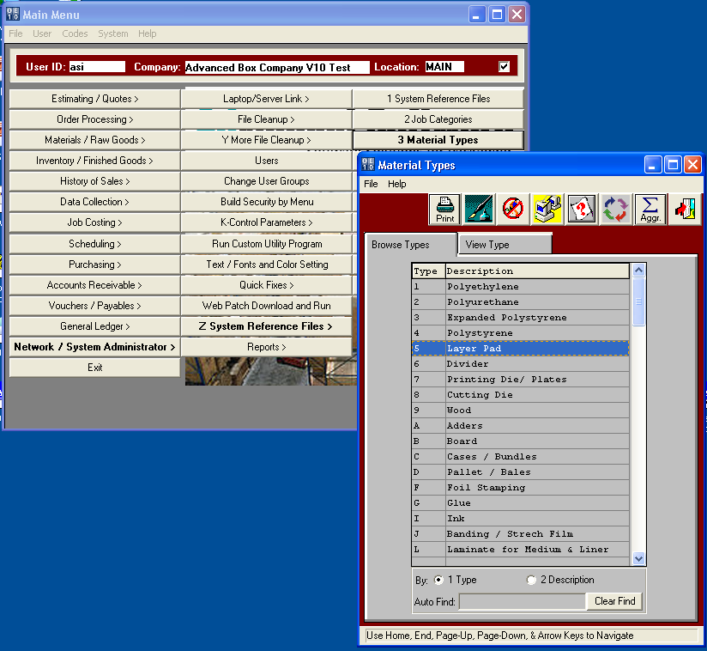

Case Dividers, Layer Pads and Case Bags

Adding new materials to the raw materials file for case dividers, case layer pads or bags for cases can be created as material types 5 or 6. The cost must be created on the Vendor Cost Matrix folder.

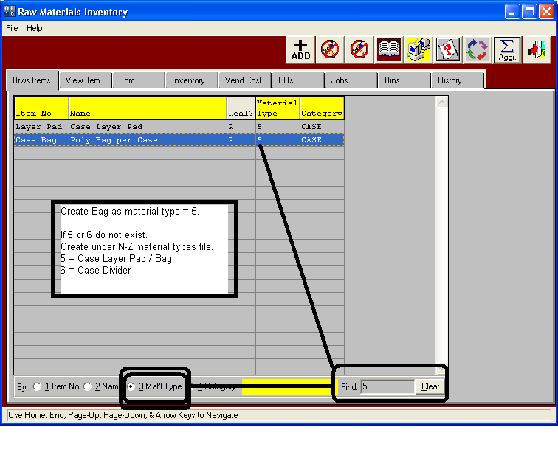

Case Dividers, Layer Pads and Case Bags

Folding carton estimates allow adding the case dividers and case layer pads or bags for cases defined as material types 5 or 6. The estimator indicates the number of bags, pads or dividers per case. The number of boxes per packing code (Case) determines how many cases for the estimate, thus how many layer pads, dividers or bags.

